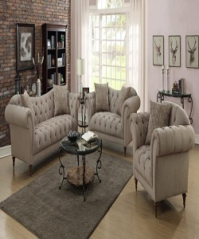

Light Brown sofa

$209.15

Availability: In stock

Description

Fort living sectional sofa light brown by home elegance leather Chelsea home Colby sofa set light brown.